SUNFILL ADVENTURES
Time: 8:30 am – 4:30 pm
7 Stops – 7 Days a Week!

LOOKING FOR A TASTE OF PARADISE? RIDE THE WAVES FROM BARRATERRE DOCK

While the Exuma Pigs are the highlight of many of the best excursions in Exuma, that’s not the first place you visit on Exuma day excursions. Once in Exuma, you either take a taxi or private rental to Barraterre Dock – see link/directions below:
https://maps.app.goo.gl/ygB9TjMehyffioJZ6?g_st=ic OR simply contact us via 242-456-4110.
During the tour, experience eye-catching scenic views passing by plush homes and Cays of famous celebrities’ like David Copperfield, John Fry of Fry’s Electric, Oprah Winfrey, Nicholas Cage, Johnny Depp, and Faith Hill just to name a few.
Our veteran Captain and captivating team not only creates an ambiance with relaxation for body, mind and soul but prepares a special blend of our secret ingredient. Enjoy sipping an aromatic cocktails and beers with notes of mango on the open waters, admiring a panoramic view of the picturesque waters, the most beautiful in the entire World. 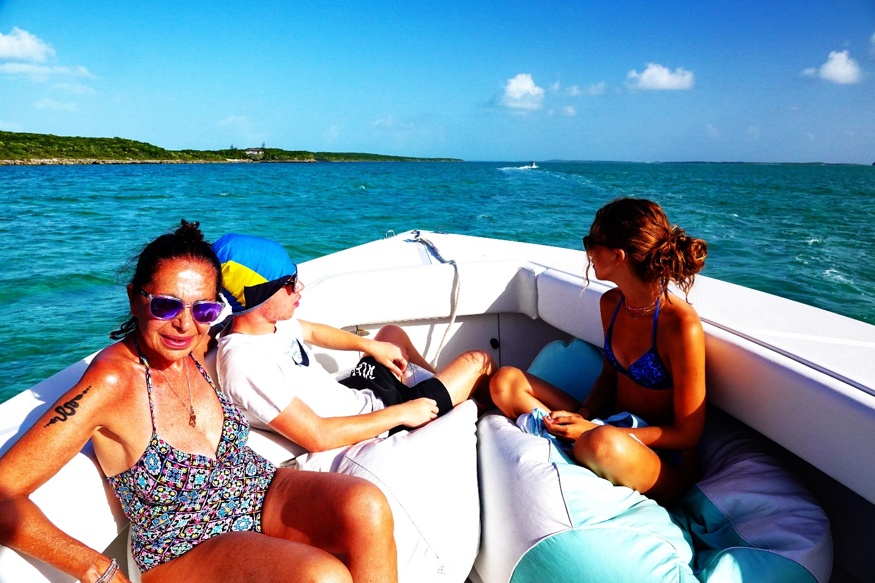
Oh…The music is like magic!! Exuma is the gateway BAHAMAS!!

STOP 1. Compass Cay
As if swimming with pigs and hanging out with iguanas weren’t enough, one of the best excursions in Exuma also let you stop at Compass Cay Marina. Once you arrive, you won’t have to look far to find the friendly nursing Sharks that’s places the small tropical island on international maps everywhere.

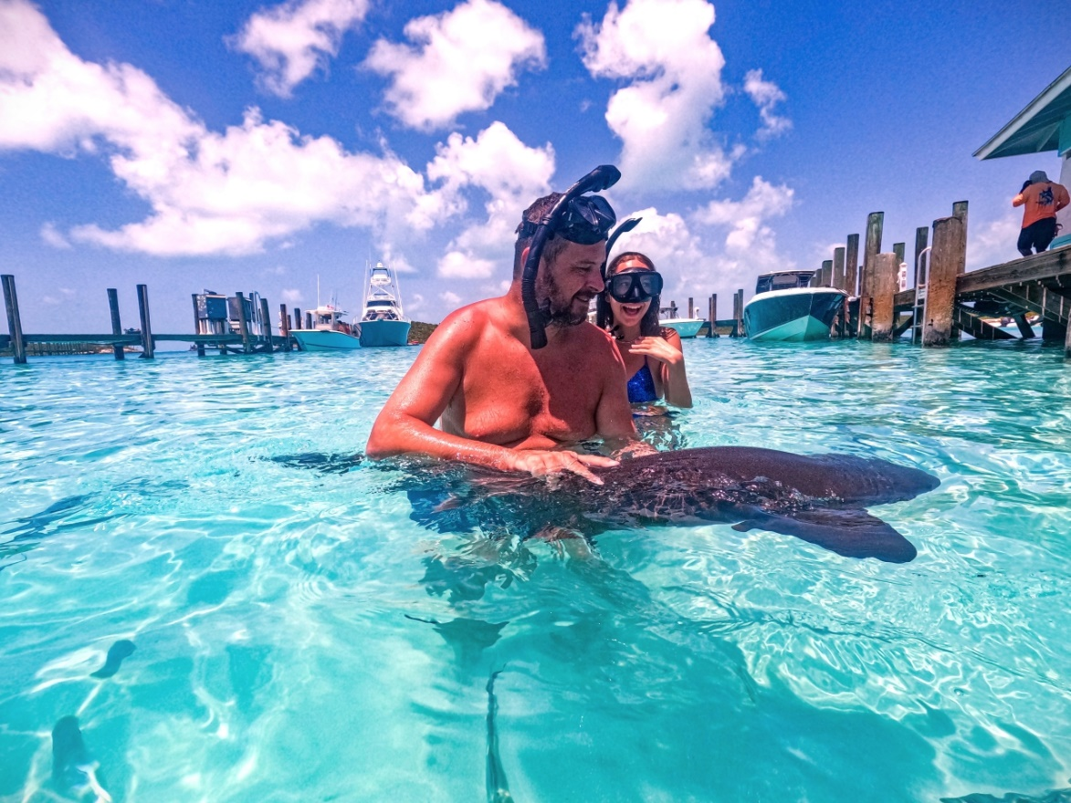

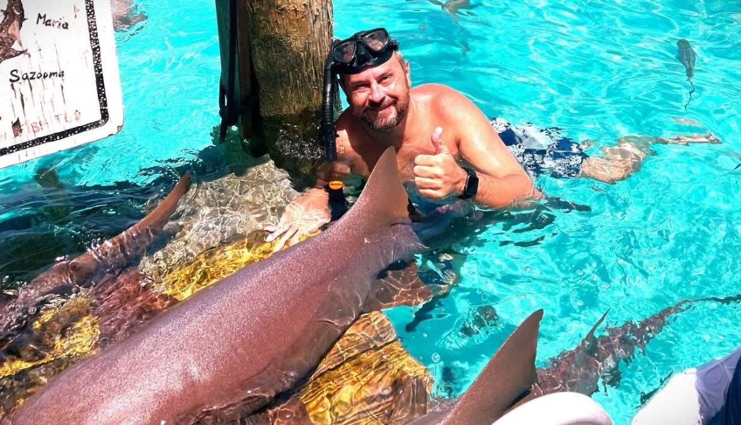

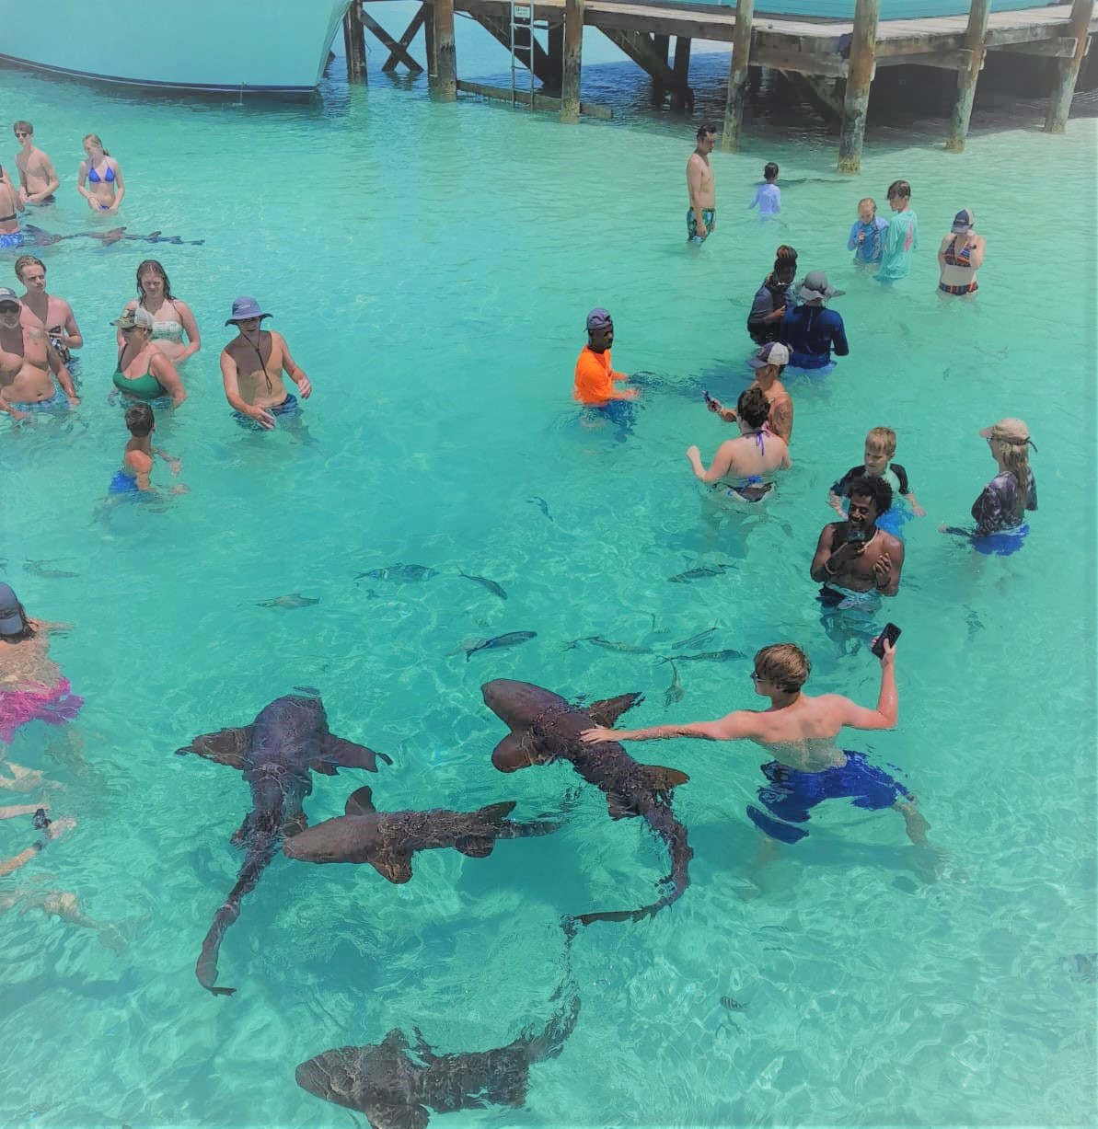

STOP 2. Pipe Creek
Breathtaking excursions to the Exuma Cays take you to some of the prettiest places in the country. This excursion will truly make you feel like you’ve stepped into a postcard in Pipe Creek.
When the tide rolls back at Pipe Creek, you’ll see sugar-white sandbars pop out of the azure water. One of the best excursions in Nassau, you don’t just look at these sandbars from afar – you also get to walk on top of them.
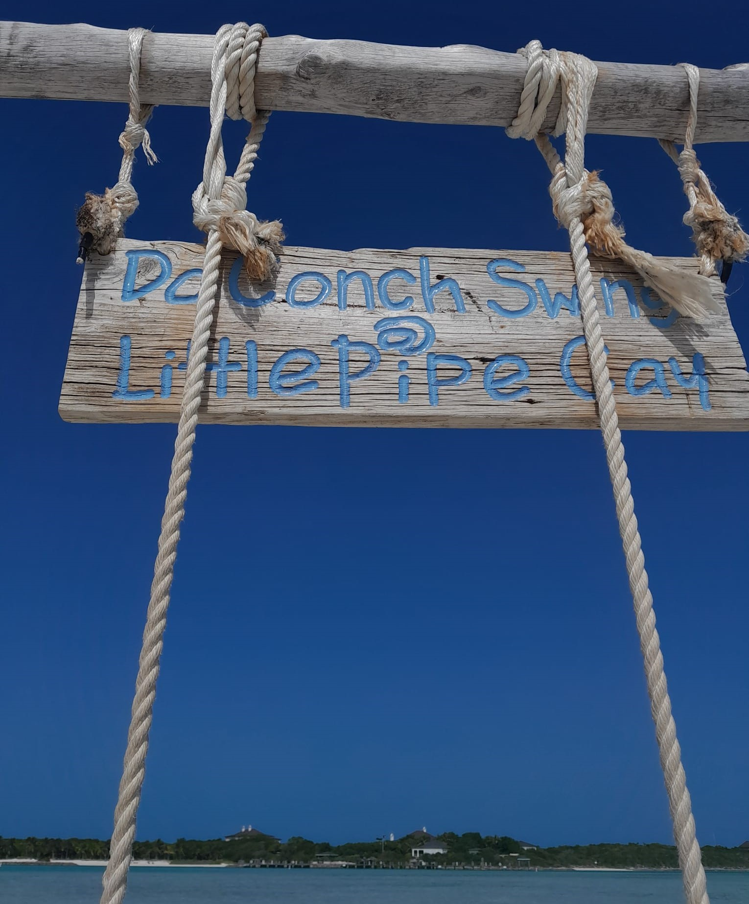
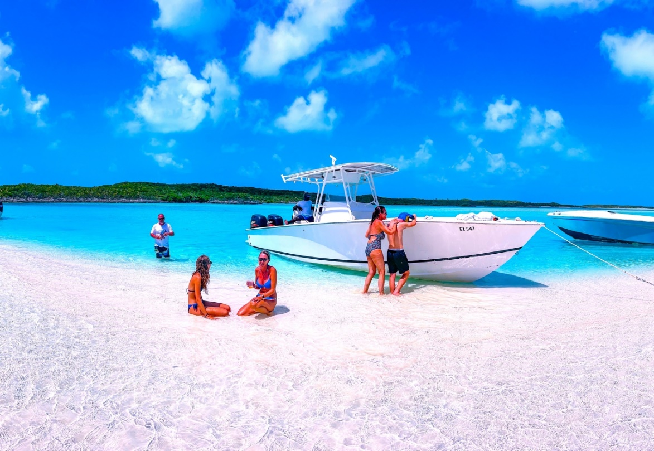

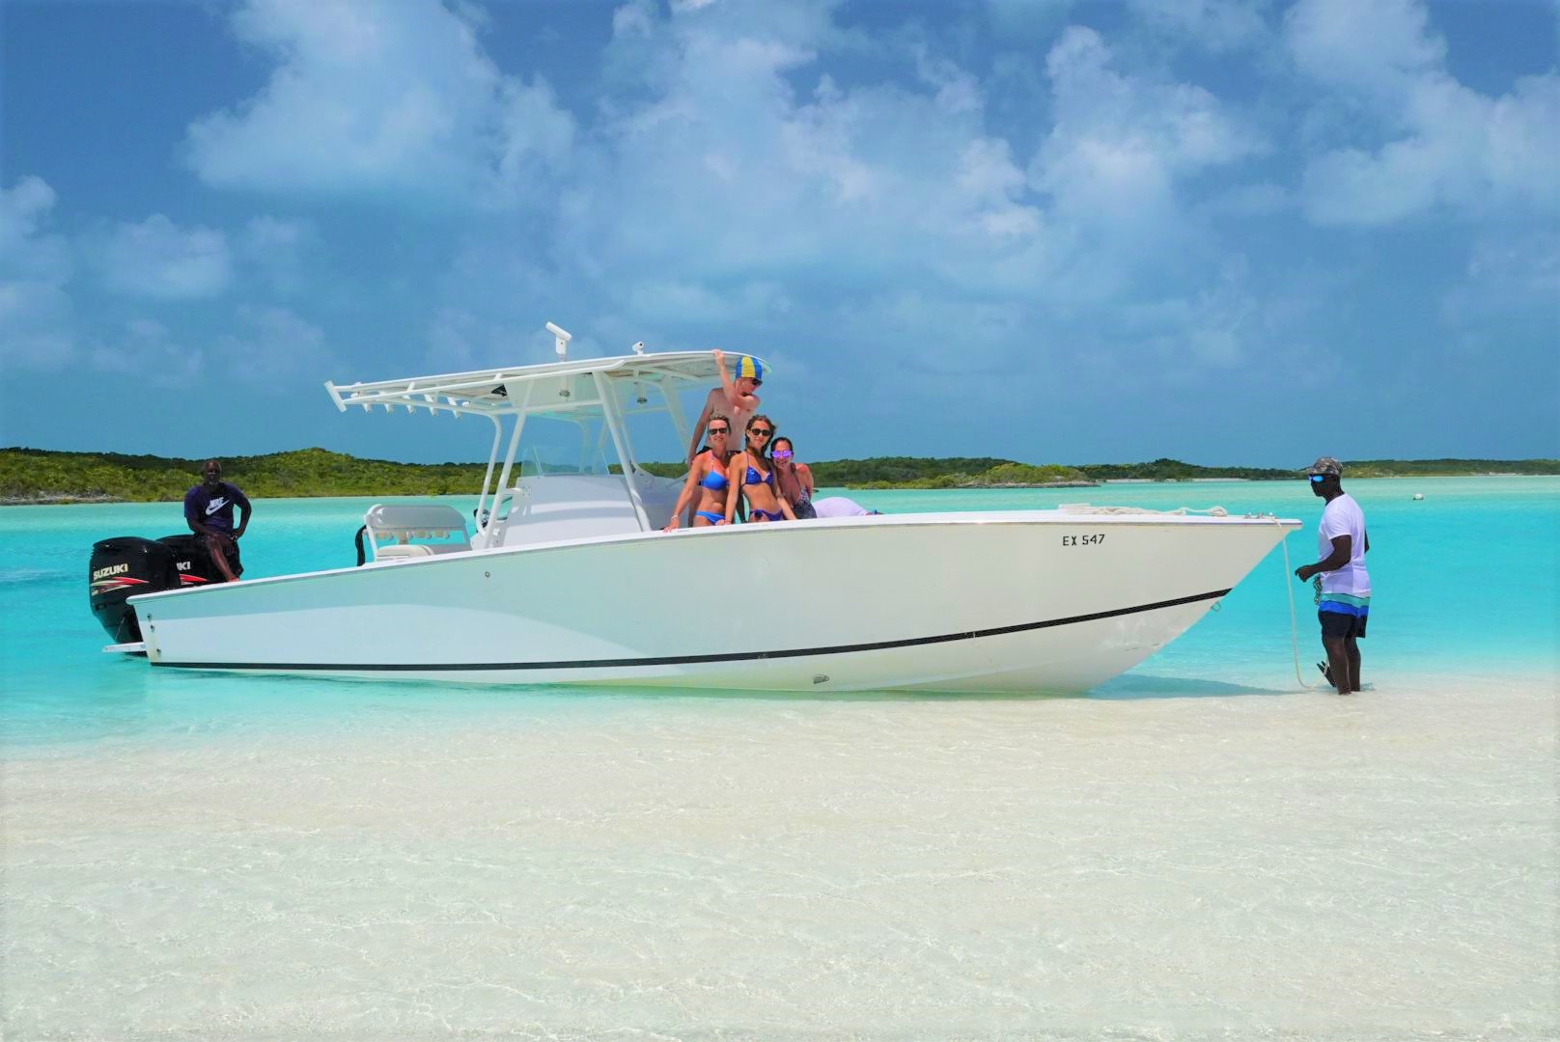

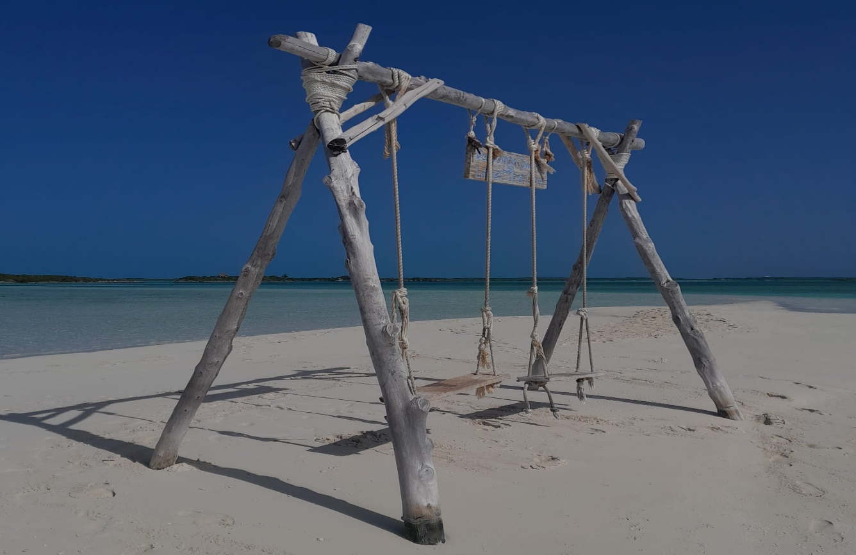

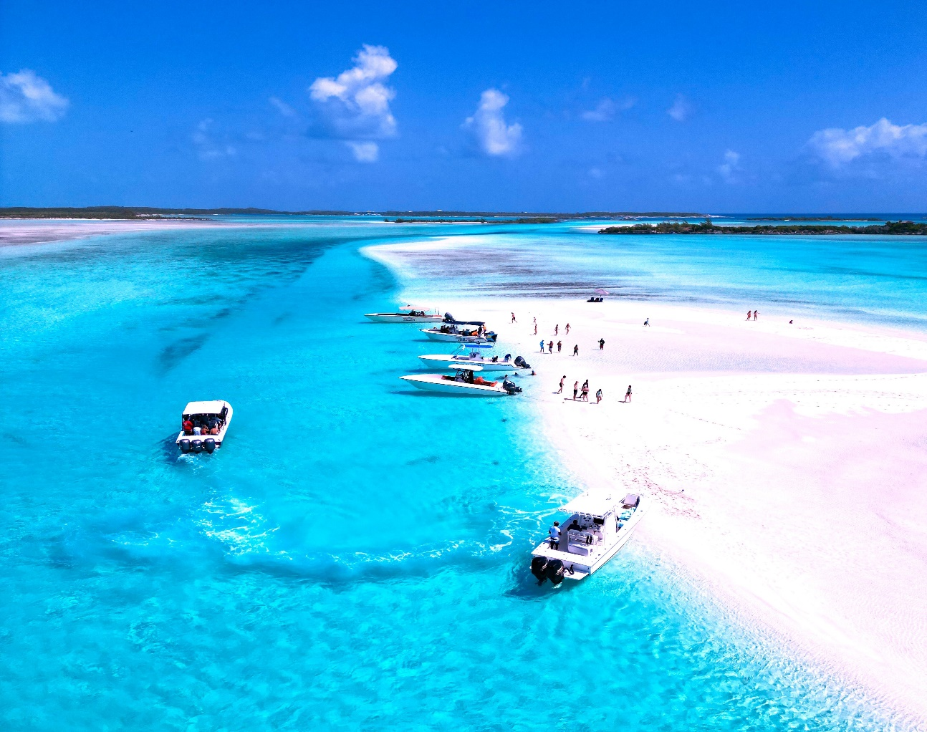

STOP 3. An Underwater Plane Wreck
Travelers can find another great Exuma snorkeling opportunity at an underwater plane wreck. Decades ago, when the Colombian drug cartel Pablo Escobar was in his element, his smuggling vessel crashed down in the warm Bahamas waters. Saddled to the brim with marijuana, the pilots unfortunately were unable to survive the wreck. However, since its watery crash, the site has transformed into a place of life.
Today, this site is home to tropical fish and other marine life. As the waters around the plane are quite shallow, it’s also one of the best Exuma snorkeling locations. Diving down to examine the vessel up close is one of the top excitement on this excursion.

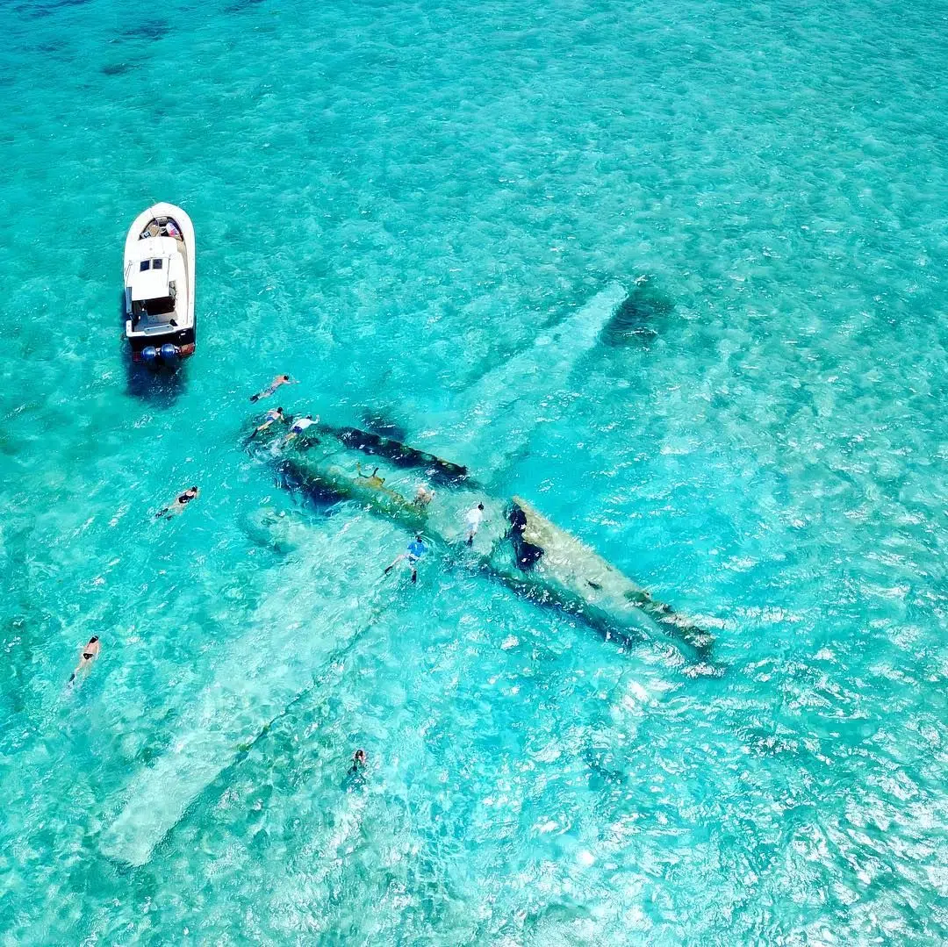

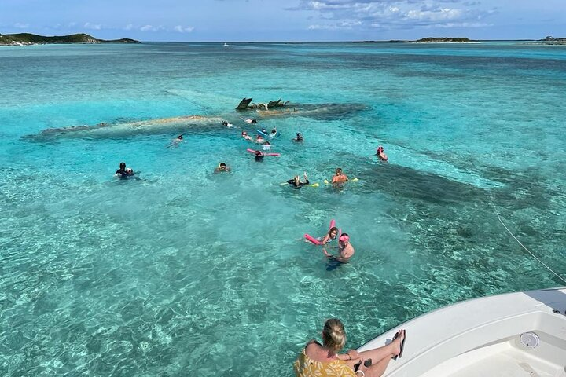

STOP 4. The Exuma Pigs
The Swimming Pigs are the climax of the best excursions in Exuma. Found on Big Major Cay (the official name of Pig Beach), the pigs have become one of the most famous attractions in the country over the past several years.
The Exuma Pigs reside on an isolated island. No one is exactly sure how they arrived there, and several stories surrounds their origins. Today the pigs are happy to greet everyone who arrives on their shore. These precious mammals are privilege to have Farmers, Fishermen, Tourist and other boaters feed them on a daily basis over the years.

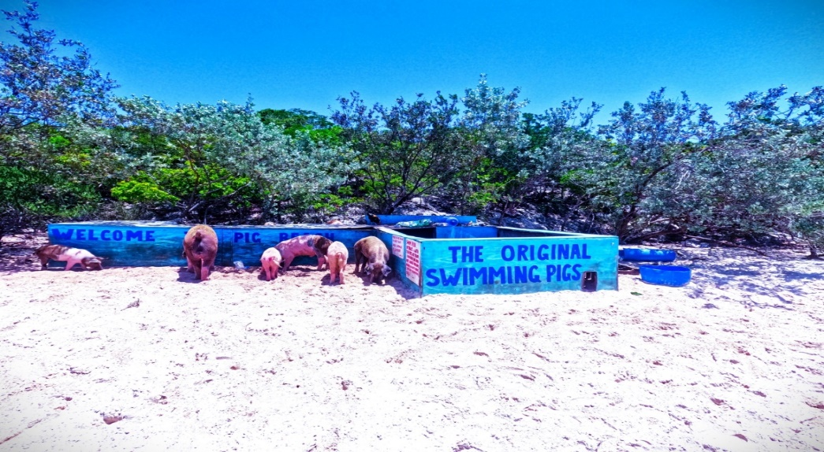

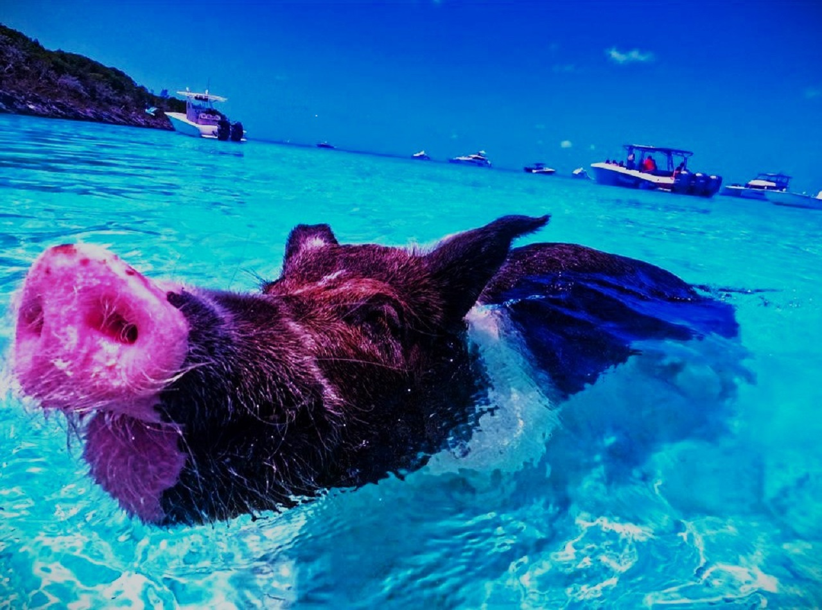


STOP 5. *** Lunch at Staniel Cay Yacht Club or Buffet Style at Black Point (not included with cost)***

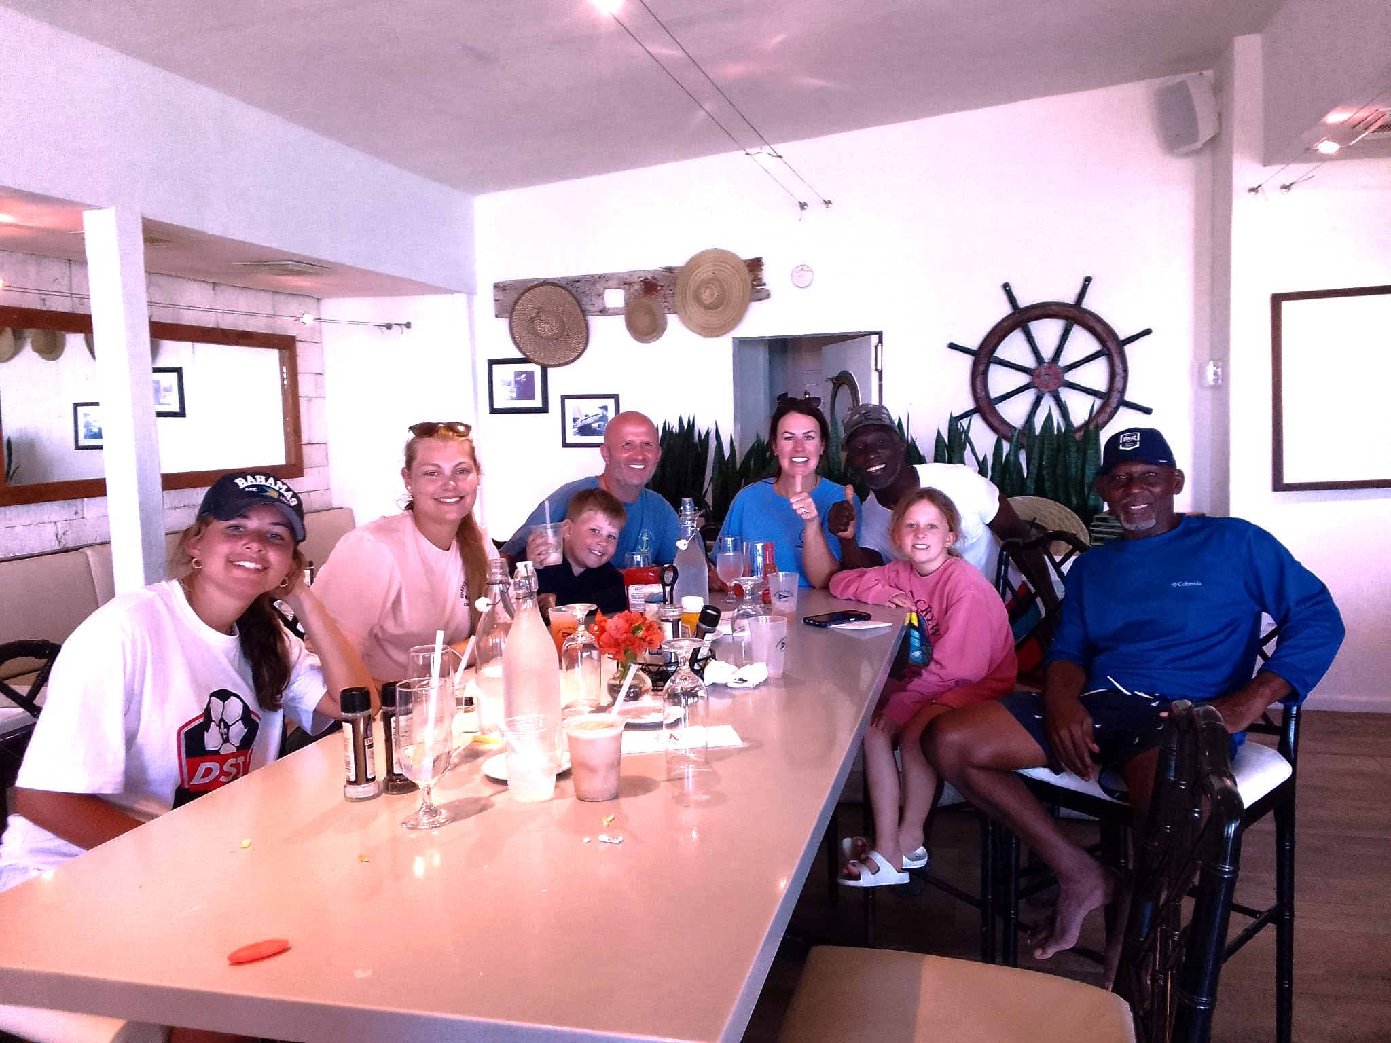

STOP 6. Thunderball Grotto

If you’re looking for additional snorkeling opportunities, Thunderball Grotto is one site you won’t want to miss out on. Its spectacular site is unrivaled! Another notable excursion in Exuma Cays take you to the Thunderball Grotto….. a system of underwater caves full of marine life. From reefs and lobsters to fish and more, you can see all sorts of creatures beneath the surface of the water. The underwater cave system is so beautiful, it was featured in the James Bond film Thunderball (hence its name).

Whether you’re a fan of classic Hollywood films or are just on the hunt for the top Exuma Adventures, Thunderball Grotto deserves a spot on any Bahamas itinerary.

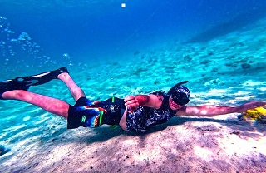

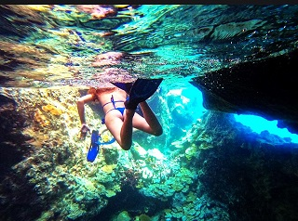

STOP 7. Leaf Cay
On the best excursions in Exumas, you don’t just get to see the Swimming Pigs. At Leaf Cay, another island in the Exumas, you also get to see endangered Iguanas.
The Bahamian northern rock iguana is a colorful species of lizard that has seen its numbers decline in recent years. As less than 5,000 animals still lingers in the wild, Leaf Cay remains one of the best places in the Bahamas to see them.
As you land on Leaf Cay, you’ll see these beautiful creatures slither out from the tropical vegetation and make their way to the beach. Besides appreciating them, you’ll also have time to explore their island. While all of the islands in the Bahamas are beautiful, Leaf Cay is one of the prettiest!

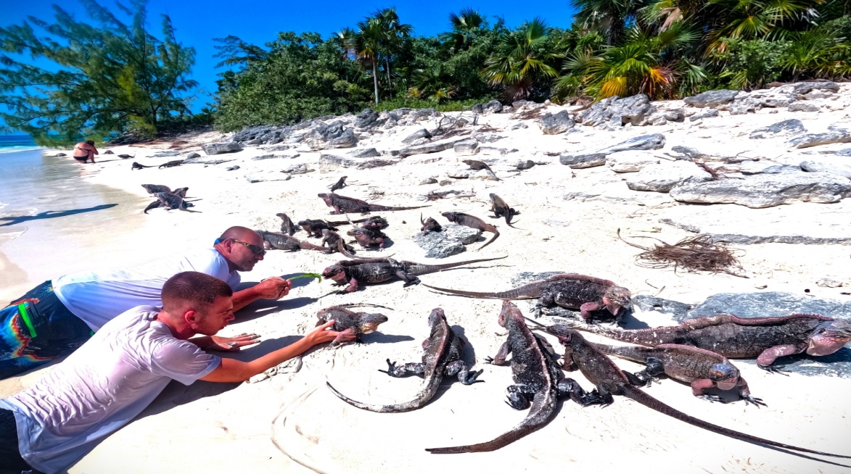

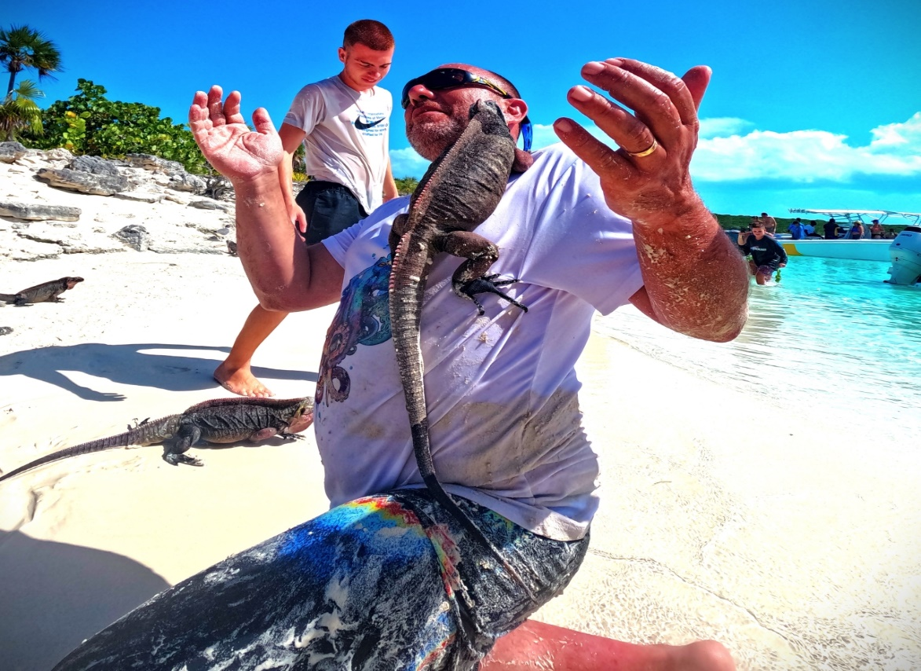

PARADISE DELIVERED !!! RIDE THE WAVES BACK TO BARRATERRE DOCK….

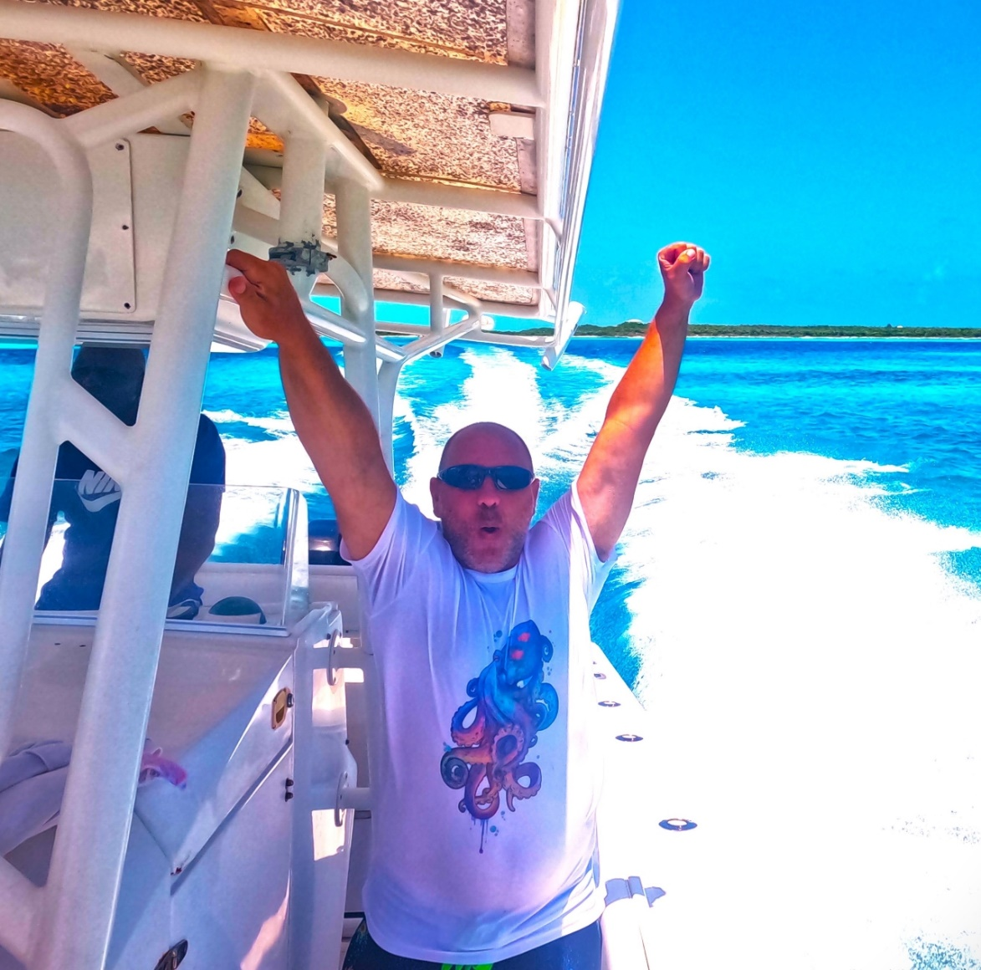

THANK YOU FOR CHOOSING SUNFILL ADVENTURES !! SEE YOU AGAIN SOON

